Sarah Thieneman
Making Barnard History
Professor McCaughey
Spring 2015
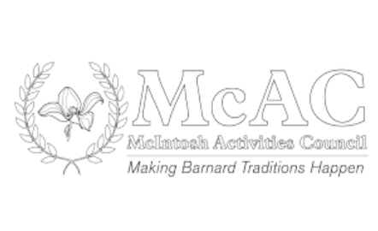

History and Role of the McIntosh Activities Council: McAc

For my third presentation I decided to explore the history of the McIntosh Activities Council (McAc) at Barnard. McAc is part of the Student Leadership Collective, which includes the Student Government Association and the Governing Board at Barnard College. McAc committees meet for one hour each week to plan events. This semester I was a member of the McAc Wellness Committee, which is responsible for planning events that promote a variety of wellness-related events, including physical, mental, emotional, and sexual health. The committee also promotes relaxation, exercise, and healthy living at Barnard. The other committees of McAc include Network, Action, Multicultural, and Community.
The first mention of the McIntosh Activities Council in the Barnard Digital Archives was in a Barnard Bulletin from April 29, 1970, which discussed a Balkan Folk Festival that McAc was co-sponsoring.
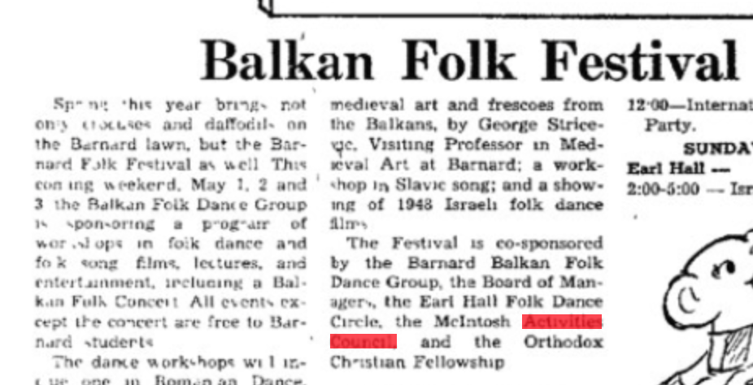
Photo from the Barnard Bulletin, April 29, 1970, courtesy of the Barnard Digital Collections

There was no exact mention in the Digital Archives announcing the founding of McAc. Later mention of McAc came in an October 21, 1970 article in the Barnard Bulletin about student government, which expressed doubt about how control of the McAc budget would be used. Later on in the Bulletin article, not pictured, discussed the fact that there was apathy in the community at Barnard in 1970 and expressed hope that McAc’s activity planning would ease that.
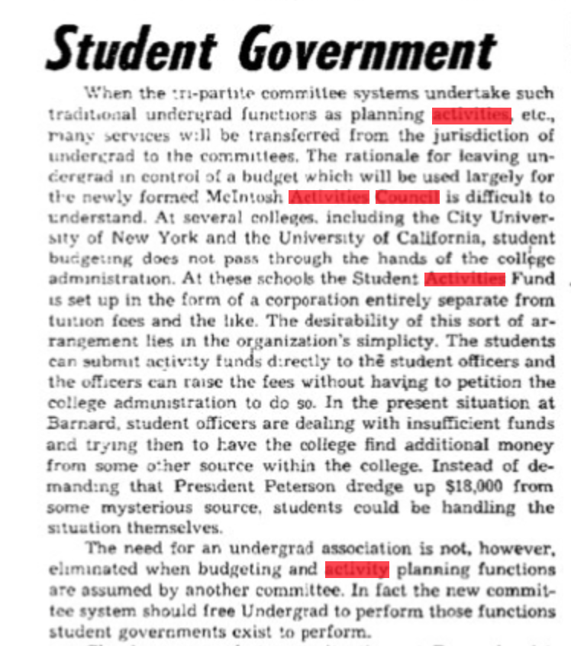
Photo from the Barnard Bulletin, October 21, 1970, courtesy of the Barnard Digital Collections

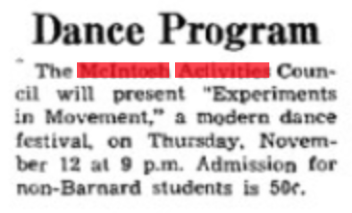
Photo from the Barnard Bulletin, November 4, 1970, courtesy of the Barnard Digital Collections
A Bulletin article from just a couple weeks later, on November 4, 1970, announced that McAc was hosting a modern dance festival. It seems that while some seemed confused about McAc’s structure initially, it did go on to quickly begin planning events for students.
The 1971 issue of the Barnard Mortarboard paints a more complete picture of McAc, with a description about the council that included its social and special events committees as well as dinner programs and recreation activities. It fleshes out the types of events that McAc planned, such as weekly films, open houses, monthly speakers, bridge nights, bowling, weekly dinner speakers, student-faculty coffee hours, and special events such as ski trips, dance series, concerts, poetry readings, mixers, square dances, art exhibits, and holiday-themed foods such as green beer for St. Patrick’s Day, cherry pie on Washington’s birthday, and sangria for the first day of spring. This plethora of activities seems like possibly even more than Barnard has now, especially the weekly ones such as weekly films and dinner speakers. Some activities have possibly been taken over by Student Life, such as some of the special events. One interesting thing to note is that in the Mortarboard photo below, there are men pictured in the McAc photo and listed as part of the McAc council—it seems that Columbia students were involved and a part of McAc.
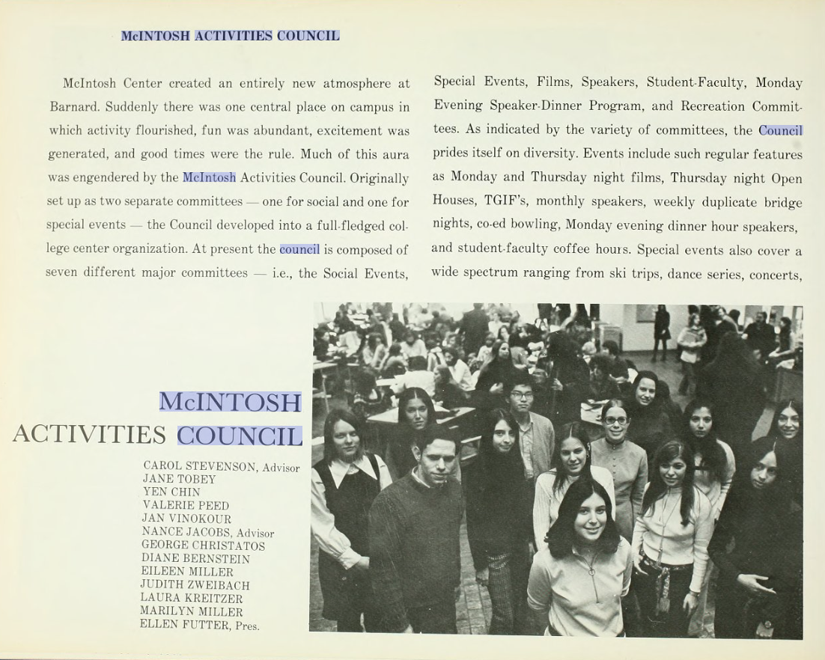
Photo from the Barnard College Mortarboard 1971, courtesy of the Barnard Digital Collections

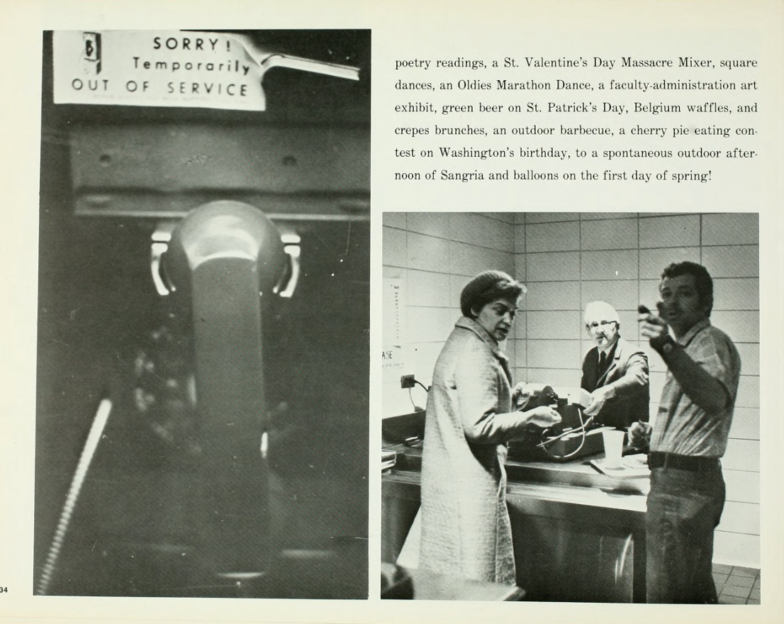
Photo from the Barnard College Mortarboard 1971, courtesy of the Barnard Digital Collections

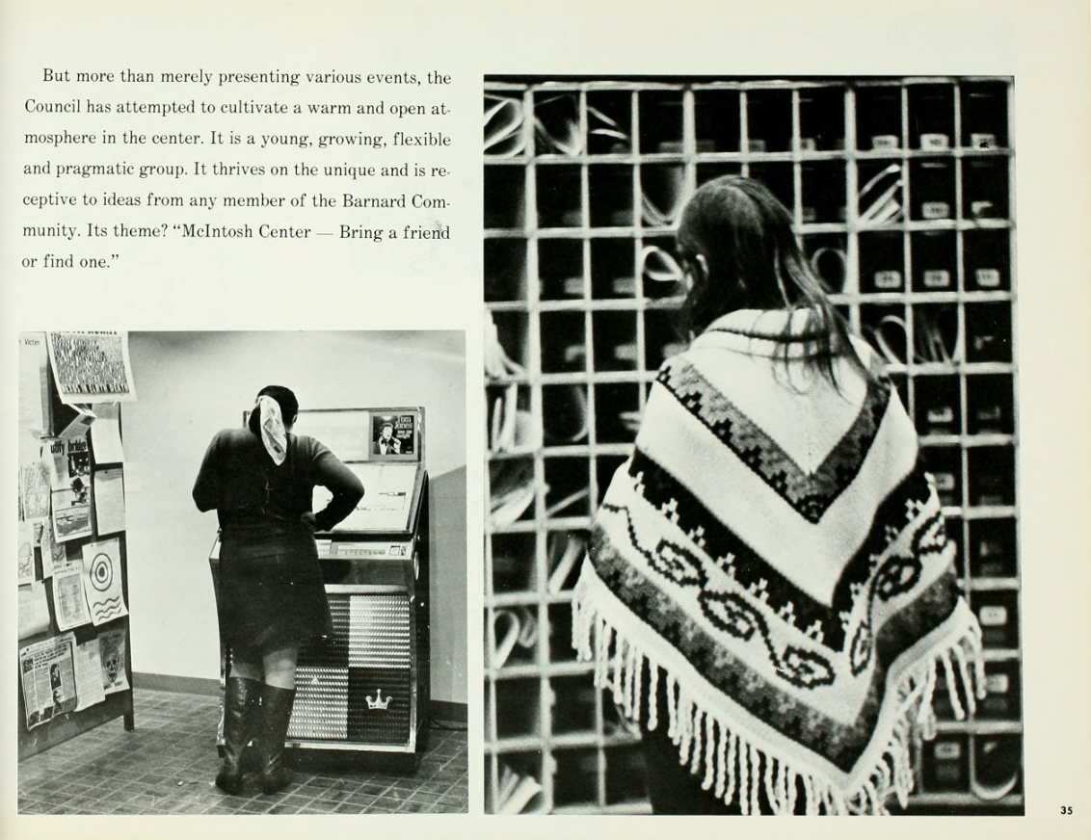
Photo from the Barnard College Mortarboard 1971, courtesy of the Barnard Digital Collections

Another page from the same Mortarboard, 1971, describes the purpose of the council: “the Council has attempted to cultivate a warm and open atmosphere in the center. It is a young, growing, flexible and pragmatic group. It thrives on the unique and is receptive to the ideas from any member of the Barnard Community. Its theme? ‘McIntosh Center— Bring a friend or find one.’”
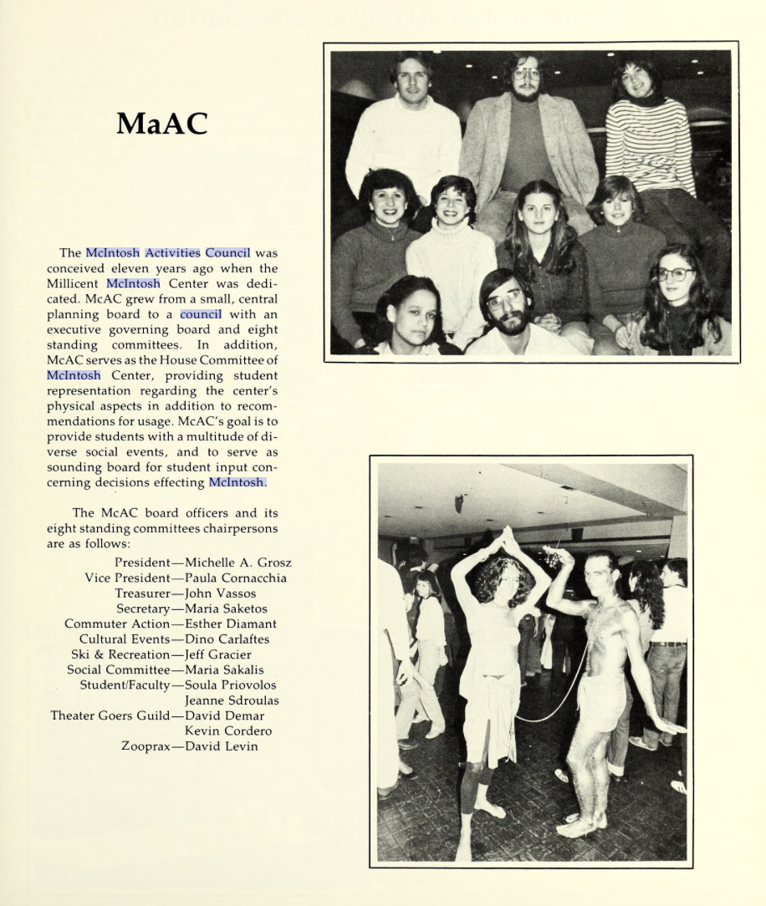
Photo from the Barnard College Mortarboard 1981, courtesy of the Barnard Digital Collections

Ten years later, the Mortarboard in 1981 provides another look into McAc, saying that it was “conceived eleven years ago” (1970) and that it grew from a small board to a large council. Again, there are men on the McAc board committee, presumably Columbia students.

Modern McAc may be different, but the goal of cultivating an atmosphere of community still thrives, especially in McAc’s phrase, “Making Barnard Traditions Happen.” Today, McAc helps plan popular Barnard tradition such as Big Sub, Midnight Breakfast, the Emily Gregory Dinner, Barnard Spirit Day/Week, and other events throughout the semester. Some current McAc events include a paint night, a spa day, and a service fair.
McAc members are optimistic about the sense of tradition that McAc provides and the unique opportunity it provides to students. Rivka Holzer (BC ’15), the chair of the McAC Wellness committee, says, “I love McAc because it’s an incredible opportunity for students to plan huge events that they otherwise wouldn’t be able to. It’s a built in support network for planning events, which I think is really cool.” She added, “The cool thing about it being a student organization is that I got to plan events. Like last year we did this event on disability, which was really meaningful, and I don’t know what other forum it could have been done in… I cried. We had students talking about their disabilities.” Additionally, Alex Peaslee (BC ’15), the President of McAc, added that, “One thing I love about McAc is that we’re the only organization on campus that gives students to have leadership roles on campus. We give so many students leadership development, we give them money and opportunities to plan as many events as they want.”
The McIntosh Activity Council’s 45-year history at Barnard has been one focused on encouraging community and tradition at Barnard. McAc maintains annual events such as the Midnight Breakfast and Spirit Week, as well as new events throughout the year to entertain, educate, involve, and relax students. As McAc continues to evolve, its members seem to find it a great place to learn about event planning and to become more involved in community traditions, which goes back all the way to 1971, when the Mortarboard described the council as “attempt[ing] to cultivate a warm and open atmosphere.”

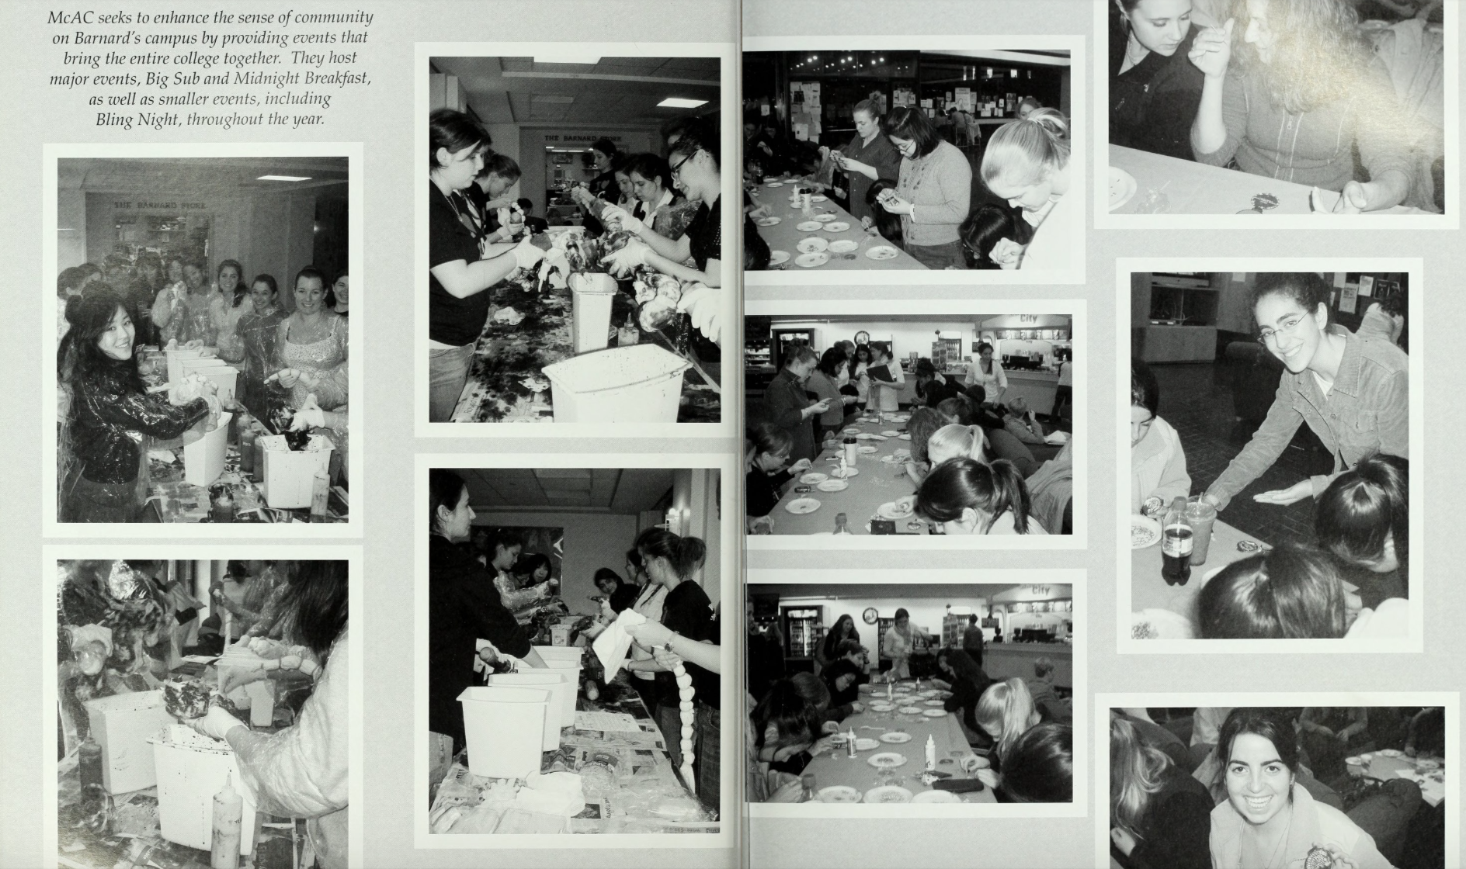
Photo from the Barnard College Mortarboard 2007, courtesy of the Barnard Digital Collections
“McAc seeks to enhance the sense of community on Barnard’s campus by providing events that bring the entire college together. They hose major events, Big Sub, and Midnight Breakfast, as well as smaller events, including Bling Night, throughout the year”

