Sarah Thieneman
Making Barnard History
Professor McCaughey

The Early Period of Mount Holyoke Seminary and Barnard College

Women’s colleges, which began to gain popularity in the nineteenth century as a way to educate women to be mothers and teachers, and later to educate them in a similar fashion as men before coeducation was allowed, are most famously reflected in the Seven Sisters group of colleges which were linked to Ivy League universities. The Seven Sisters included Mount Holyoke College (1837), Vassar College (1861), Smith College (1875), Wellesley College (1875), Radcliffe College (1879), Bryn Mawr College (1885), and Barnard College (1889). It is interesting to note that Mount Holyoke College was the first of the Seven Sisters to be founded, and Barnard College was the last; this short paper will compare the two.
As we have discussed a little in class so far, Barnard College first opened in October of 1889. Its beginnings came from the President of Columbia Frederick Barnard’s idea of co-education. He wanted women to be admitted to Columbia University, and tried to pitch the idea of co-education to the Columbia trustees from 1879-1881. The trustees were unresponsive to his idea, and after 1881 Barnard stopped proposing it. In a similar vein, in 1883 a young woman named Lily Blake went to President Barnard trying to get women admitted to Columbia, however, like Barnard’s earlier attempts this was unsuccessful until the idea for a separate institution, Barnard, was formed.
It should be noted that President Barnard had passed away before Barnard College opened its doors, and therefore was not aware of the intentions to name the college after him, which most likely stemmed from the political idea of wanting to link the two institutions. While arguably a women’s college defeated the idea of co-education and reinforced the decision, Barnard College was founded on the premise of giving women a similar education as that of the men at Columbia University. Taught by many of the same professors as the men at Columbia, the women would graduate prepared to be teachers, writers, or other similar professions. Barnard’s early years had many different leaders, including Ella Weed, Emily James (married name Putnam), and William Brewster. These first administrative chiefs only stayed for a few years each, so in the beginning there was no solid dean or president who stayed for a long time to guide the college in a certain direction. The first longstanding Dean (the title of this position was later changed to President) was Virginia Gildersleeve in 1911, who was a Barnard graduate herself and served until 1947.
Mount Holyoke College’s story is different, especially given that the college started much earlier than Barnard and in a more country setting. Founded in 1837 by Mary Lyon as the Mount Holyoke Seminary in South Hadley, Massachusetts. Accroding to Horowitz in Alma Mater, “ the transformation that Mount Holyoke wrought in higher education profoundly influenced the women’s colleges that followed in its wake” (Horowitz 9). While we might interpret the term “seminary” as a more religious term today, Horowitz notes that “in the early nineteenth century the word seminary began to replace the word academy. The new word connoted a certain seriousness. The seminary saw its task primarily as professional preparation. The male seminary prepared men for the ministry; the female seminary took as its earliest job the training of women for teaching and for Republican motherhood” (Horowitz 11).
While the female seminaries didn’t offer the classics that the male ones did, women could still be taught “history, philosophy, modern languages, and natural sciences” (Horowitz 11) in order to be teachers. Mount Holyoke’s beginning was intertwined with its founder Mary Lyon, whose work “linked the highest available course of study to a system of discipline and a form of building that propelled its students outward into the world (Horowitz 12). Seventy percent of Mount Holyoke graduates became teachers. Unlike Barnard, and probably due to the earlier time period in which Mount Holyoke was founded and its status as a seminary, Mary Lyon “saw her school as God’s agent, bringing women to Christ” (Horowitz 15), however, Lyon’s ideas also “took women out of tradition and brought them into modern times” (Horowitz 16). Interestingly, this had a profound effect on Mount Holyoke, which was still considered a seminary in 1887. To make the shift to a college, it had to reshape the curriculum and build a new campus (Horowitz 223).
Lyon’s seminary framework had “apostolic succession which elevated favored students to teachers and principals” (Horowitz 223). Public confessionals were held. Compared to Barnard, which had no solid leadership until 1911, “Mary Lyon built [Mount Holyoke] more solidly than she knew” (Horowitz 224). Mount Holyoke felt competition, especially financially, from Wellesley and nearby Smith, especially after “the seminary’s position eroded to that of a preparatory school for the colleges, and an ineffective one at that, for it did not offer the classical training required for college admission” (Horowitz 224).
Mount Holyoke was positioned as an opposite to the farm, which would impose schedules instead of natural rhythms. I find this interesting because Mount Holyoke was still considered quite a country school; additionally, Barnard couldn’t have really set itself up as an opposite to farm life because it was in New York City, putting it in a unique position. While Mount Holyoke was the model of inspiration for many other women’s colleges, its original structure as a seminary caused problems for it later in the late 1800s, as it strived to reinvent itself as a college rather than a preparatory school. Perhaps in Barnard’s case, not having a solid head for molding the school was more of a blessing in that it didn’t have to reshape itself from a very strong view later.
I do think that a comparable example of Mary Lyon’s influence on Mount Holyoke could be Barnard’s initial incorrect assumption of the type of students who would be attending (namely, rich young women from prominent American families). While the trustees may have imagined that the rich, prominent daughters of other trustees or important families would attend Barnard, in reality many middle class or immigrant women were attracted to Barnard’s message of higher education for women. The ideal, prominent woman that the trustees envisioned probably went instead to a “country school” like Wellesley. However, the trustees still planned Barnard around these high standards, even going as far as to decorate Brooks Hall in the finest manner and using the most prominent decorators in the city; the dormitory did not fill to full capacity (it was too expensive for the average Barnard student) and rooms had to be rented out to faculty.
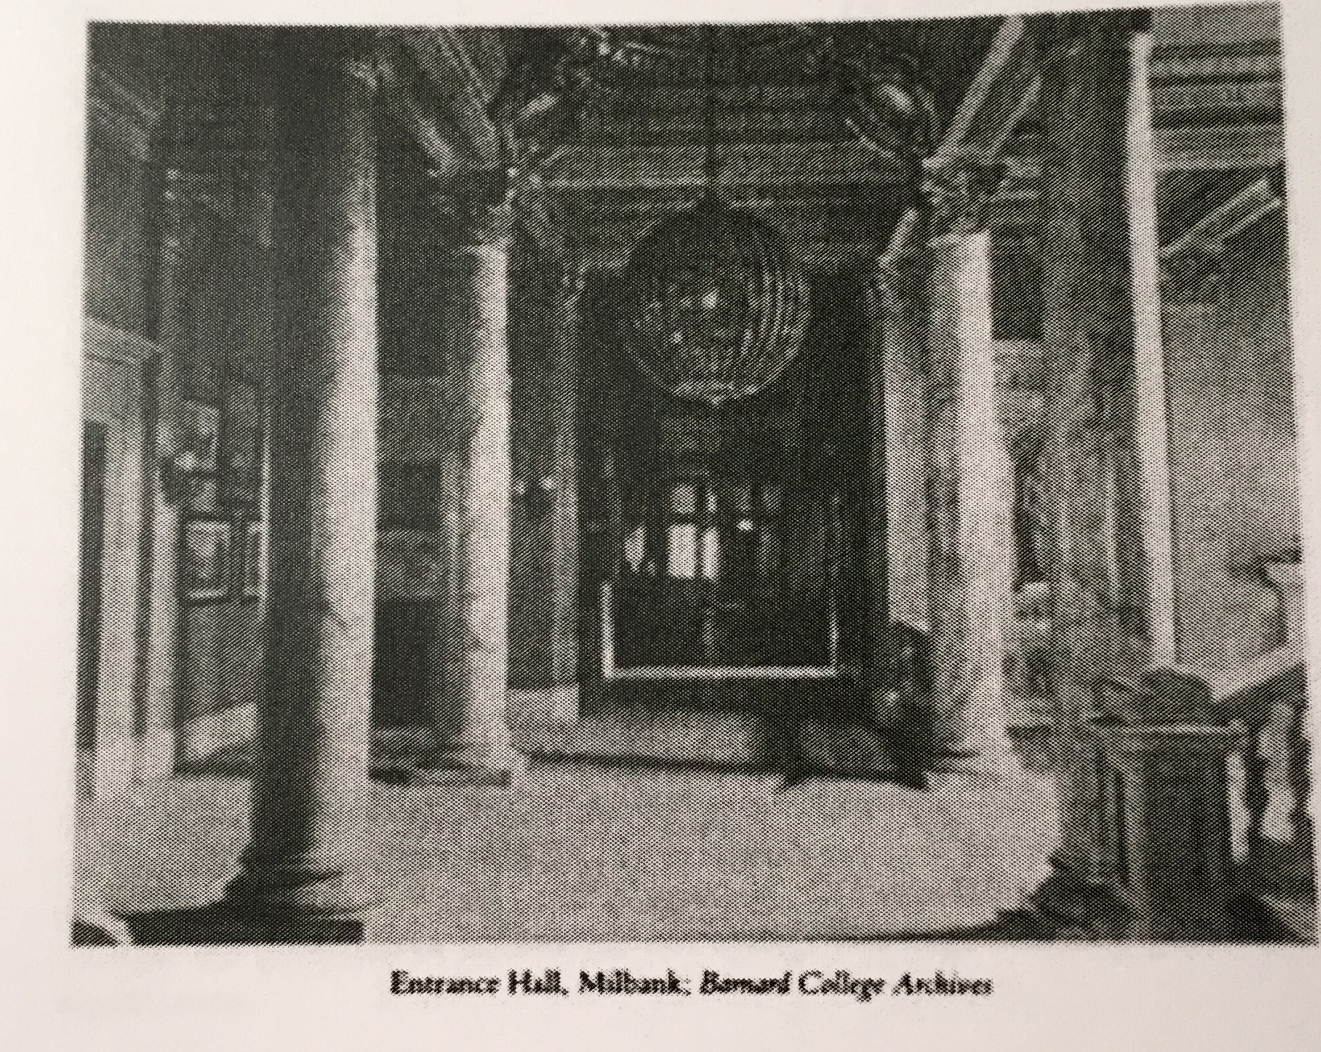
Photo from Alma Mater by Helen Lefkowitz Horowitz, page 140
It is interesting to note that from the dates of the other Seven Sisters schools, Mount Holyoke College (1837), Vassar College (1861), Smith College (1875), Wellesley College (1875), Radcliffe College (1879), and Bryn Mawr College (1885), Barnard’s founding in 1889 was four years later than the sixth Seven Sister, Bryn Mawr, and that by that time Mount Holyoke had been running for fifty-two years, and had already celebrated its first half-century, which was a time of reflection on the seminary’s past and future (Horowitz 223). While this put Barnard at a certain disadvantage in terms of attracting the prominent young women the trustees initially envisioned as Barnard students, it also gave those involved the opportunity to study other women’s colleges.
For example, Horowitz notes in her book that, “under [Ella Weed’s] leadership Barnard did not repeat Vassar’s mistakes. In language reminiscent of President Raymond, Ella Weed set out the rationale for the liberal arts at Barnard. She wanted only students who met Columbia’s entrance standards, which included Greek. She required students to take the regular sequence of courses. She fought against imitating Radcliffe’s policy of accepting special students who came only for a few courses” (Horowitz 136). By observing other women’s colleges history and issues, Ella Weed was able to avoid certain pitfalls, such as trying to prevent women from only taking a few classes at Barnard rather than completing a full degree like what happened at Radcliffe.
I found some interesting similarities in the finances of both schools, as they both had problems procuring enough money or ensuring the flow of money they already had in the beginning. While many other women’s colleges were started with large sums of money, Barnard College and Mount Holyoke Seminary both needed more financial support. In Mount Holyoke’s case, the problem was a bit more of a competitive one in the late 1800s—“Once generous, Durant withdrew his financial support from Mount Holyoke after he created Wellesley. The founding of Smith College in Northampton, only nine miles away from Mount Holyoke, posed the most obvious threat. Smith’s president and trustees came from the same Amherst intellectual and social milieu as Mount Holyoke, and in planning Smith they tried to consciously avoid Mount Holyoke’s flaws” (Horowitz 224).
Additionally, Horowitz also notes that while at the time of the founding Mary Lyon had “denied the value of ‘brick and mortar’” (Horowitz 18), she soon came to realize that the school would need endowments. However, instead of turning to the richest people she knew, Lyon asked for donations from like-minded people, “‘the more humble in life, led forward by their own ministers… the same class of Christians who support our missionaries’” (Horowitz 18). Lyon also devised a method to cut costs for the seminary—the students would be responsible for caring for the buildings, making and serving the meals so that they wouldn’t need to spend money on servants.
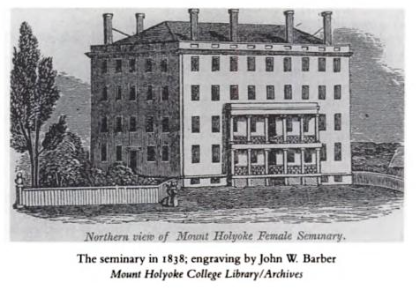
Photo from Alma Mater by Helen Lefkowitz Horowitz, page 20
Lyon’s plan to save money at Mount Holyoke seems similar to Barnard’s humble beginnings. Despite its affiliation and ties to Columbia University, Barnard was financially independent and, in the beginning, struggling. So much so that “for a four-year trial period, the nascent college struggled with small donations begged from its friends. Columbia was preparing to move uptown to Morningside Heights. Barnard wanted to follow, but it could not even raise enough to pay the annual rent of $1,800 on the modest brownstone house at 343” (Horowitz 136). Initially Barnard offered “the modest quarters of a converted house” (Horotwiz 135), and similar to Lyon’s idea for Mount Holyoke, students who couldn’t afford to stay in the regular dorms were put up in co-op apartments nearby where they would do the chores in exchange for lower housing fees. Barnard’s financial struggles caused problems with the initial people involved, especially the trustees.
During the struggle to fund a new building in Morningside Heights, morale was low; “pessimistic about the future, Jacob Schiff resigned as treasurer. He found it too ‘undignified to carry on an educational institution of such high aims by begging from door to door’” (Horowitz 136). While Mary Lyons might not have necessarily gone door to door asking for funds for Mount Holyoke, it is interesting to note that she wanted endowments from like-minded, Christian, humble people, while Jacob Schiff seemed to be envisioning high-rolling donors in line with the high aims of the college.
Another difference I noticed between the two institutions was the discussion of an affiliated institution. While Mount Holyoke was the sister school of the Andover Seminary (many Mount Holyoke women married Andover graduates as Andover men couldn’t go on a mission until they were married), it isn’t mentioned often. Barnard however, was always only a few blocks away from Columbia. The relationship between Barnard and Columbia was so important to its founding and its continuation, especially as Barnard’s professors initially came from Columbia, and Barnard students used Columbia’s resources such as the library. After Ella Weed’s death in 1894, George A. Plimpton sought “‘the strongest woman in the country’” (Horowitz 136) to head Barnard.
The trustees decided on Emily James Smith, “a brilliant member of Bryn Mawr’s first class… who had continued her classical studies at Girton and the University of Chicago. The unusual opportunity to head Barnard came to her when she was twenty-nine” (Horowitz 137). Smith was described as “gracious as well as brilliant” (Horowitz 137), though her main legacy seems to be her “ability to work strategically and effectively with Columbia’s president. Dean Smith needed both qualities for the dual task of upholding the integrity of Barnard and opening to its students the resources and offerings of Columbia. She sought to lead women into the university, not to replicate its offerings at Barnard” (Horowitz 137). Much more than Mount Holyoke and Andover Seminary, Barnard’s ties to its affiliate institution Columbia University played a significant role in its history.
As a contrast to Mount Holyoke’s strong, religious-based founding, Barnard’s founders “created Columbia’s annex to meet the demands of intelligent and well-trained New York women for a college education. Its moving spirits had no thought of changing the consciousness of young women and redirecting their lives, as did Mary Lyons or M. Carey Thomas, nor any desire to prevent them from the dangers of higher education, as did Matthew Vassar and L. Clark Seclye. Thus the planners of Barnard lacked the intense concerns for moral oversight and physical planning that accompanied the design of the other women’s colleges. Only in the twentieth century, when Barnard attempted to transform itself according to its image of a proper women’s college, did questions of student life and college buildings hold any genuine significance” (Horowitz 142). Mount Holyoke, on the other hand, was very strongly shaped by the humble and frugal Mary Lyons, who often embarrassed her friends with her poor fashion sense. Lyon’s “artlessness and her thrift are apparent in the seminary building. Mount Holyoke Seminary arose as plain and unpretentious as its founder. Its creators planned it simply, so that it yielded the most for the $15,000 available: ‘plain, though very neat’” (Horowitz 20).
While Barnard College and Mount Holyoke College had different beginnings, namely with Mount Holyoke being founded much earlier and with a religious bent as a seminary, both institutions went on to become members of the Seven Sisters, and are among the five of the original Seven that remain women’s colleges to this day (Vasser is now co-educational, and Radcliffe was absorbed by Harvard). While their histories are slightly different, even in the sense that one was a school in the city and the other in the country, and one had fluid leadership while the other had a strong model, both institutions are similar in that they came into being to educate women, doing so by scrapping together the bare minimum funds that they could to get the necessities. These institutions commitments to the highest available education for women at the time has led to strong, long-standing colleges with intriguing histories. Barnard, for example, has come a long way from Emily James Smith’s time when at a hearing of Barnard’s case “a woman apologized for not contributing to Barnard—on the grounds that so many New York City institutions claimed her loyalty that she could not give to anything so far away” (Horowitz 137).

